Surry Broadband Committee
Wednesday, 9/28/22 4 pm – 5:30 pm
Surry Town Office
Minutes
Attendees: Bill Matlock, Chris Stark, Heather Brackett, George Borowsky
Upcoming dates:
Friday, September 30 11 am Fire Station - Pre-Bid Meeting Via Zoom – Take questions and will answer them in writing to all applicants - by Oct 5
Tuesday Oct 4-Select Board Mtg 7 pm Request that the Select Board gives authority to the Broadband Committee to open the bids to review on Oct 13th. – Chris will send the bids via email to the committee to review privately. The committee with meet on Monday, October 17 at the Town Office to rate the applications. – Chris will check with the Maine Municipal Association (MMA) Legal Team to see if the Broadband Committee can meet in Exec Session if authorized by the SB. If MMA recommends to follow up with Town Attorney, the Broadband Committee will seek authorization at the Select Board Meeting to contact the attorney.
Oct 5 (as stated in the RFP) is when the Committee will email “Responses to Questions” (from pre-bid/email to all the respondents.
Oct 12 by 4 pm RFP Responses (Applications) are due
Oct 13 – Surry Broadband Committee review applications on their own (emailed)
*Monday, Oct 17, Broadband Committee meets at Town Office from 10 am to noon to rate each application using a points system (below)
Finalist – Oct 18 Select Board Mtg – SB meet with BC select the vendor in executive session/Vote SB mtg -
– to ISPs Oct 19
Criteria
The applications will be screened in 3 levels using a point system:
- Price
- Pass/Fail – which will be to satisfy each of the RFP requirements –service, speed, capacity, fiber to premises, last mile – free or minimal charge. Etc. A “Plus” note will be included for items like free modem/wi-fi, guarantee not to raise rates in the first year-modem / wi-fi , guarantee that there won’t be a rate hike in the first year.
- Graded requirements
George will draft the self evaluation (above).
October 18 Select Board Meeting –Applications/Committee go to the Select Board for a Vote – Executive Session with Surry Broadband Committee to review recommendations.
Oct 19 – Broadband Committee notifies the finalist.
Two Questions raised by Melinda of Charter/Spectrum:
1. Can the Town clarify Section 2.2, when it says that the Town is seeking FTTP that will be essentially ubiquitous throughout the town when the project is complete. Is the statement saying FTTP will be deployed for the roads outlined in the Project or does the Town anticipate FTTP for all locations in Town?
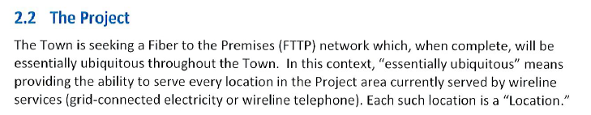
2. Has the Town considered seeking/applying for the Reach ME application process? This seems to be a great fit for funding this RFP.

-Committee will emphasize that: The bidding is on the project area but it is our intention to make fiber available to all the residents.
-Reach ME – Only eligible existing network owners and ISPs – fiber to the premises and potentially cable line extensions can apply. Goal: 100/100 mbps
-Melinda, Spectrum also made a correction about building out Morgan Bay Road – she meant “Blue Hill” not Surry: “One update – we built the Blue Hill side of Morgan Bay Road…so we will add this to our proposal as planned. Sorry for the mix up.”
October 11 meeting cancelled – Meet on October 17, 10 am at the Town Office instead

